**Final Project Part 1**

Lam Le

Cause: Gender Inequality at Workplace

Description:

Although feminism is growing to fight for equality between women and men, women are still at the lower end at workplace like receiving lower salary compared to men at the same position. The reason for this inequity is that men is believed to possess characteristics that women don’t such as leadership or courage.

Data collected/ Dimensions:

1. Earning by educational attainment

Bureau of Labor Statistics. "Median Weekly Earnings of Full-time Wage and Salary Workers in The United States in 2018, by Educational Attainment and Gender (in Current U.S. Dollars)." Statista, Statista Inc., 17 Jan 2019, <https://www.statista.com/statistics/185332/median-weekly-earnings-of-full-time-wage-and-salary-workers-by-educational-attainment/>

1. Earning ratio through time

US Census Bureau. "Female to Male Earnings Ratio of Workers in The U.S. from 1990 to 2018." Statista, Statista Inc., 10 Sep 2019, <https://www.statista.com/statistics/203459/female-to-male-earnings-ratio-of-workers-in-the-us/>

<https://www.bls.gov/news.release/wkyeng.t01.htm>

1. Earning ratio by age group

Bureau of Labor Statistics. "Female to Male Earnings Ratio of Workers in The U.S. in Q4 2018, by Age Group." Statista, Statista Inc., 17 Jan 2019, <https://www.statista.com/statistics/244383/female-to-male-earnings-ratio-of-workers-in-the-us-by-age/>

1. Earning ratio by industry

Bureau of Labor Statistics. "Gender Wage Gap by Industry in The United States in 2017, by Median Weekly Earnings (in U.S. Dollars)." Statista, Statista Inc., 31 Dec 2018, <https://www.statista.com/statistics/244202/us-gender-wage-gap-by-industry/>

1. Pay gap by occupations

Bureau of Labor Statistics. "Gender Wage Gap for The 20 Most Common Occupations for Women in The U.S. in 2017, by Median Weekly Earnings (in U.S. Dollars)." Statista, Statista Inc., 31 Dec 2018, <https://www.statista.com/statistics/244096/us-gender-wage-gap-for-the-20-most-common-occupations-for-women/>

Bureau of Labor Statistics. "Gender Wage Gap for The 20 Most Common Occupations for Men in The U.S. in 2018, by Median Weekly Earnings (in U.S. Dollars)." Statista, Statista Inc., 2 Apr 2019, <https://www.statista.com/statistics/244192/us-gender-wage-gap-for-the-20-most-common-occupations-for-men/>

<https://www.bls.gov/news.release/wkyeng.t04.htm>

I believe the data is authentic because Bureau of Labor Statistics is a governmental statistical agency that collects and processes statistical data to the American public (Wikipedia).

What I found in these data:

Despite having the same educational level, women still earn less then men.

From 2004-2018, women to men earnings ratio has increased 5%, but the ratio is still at roughly 80%, which means a woman would earn about 80% of the amount a man in the same position would earn.

Younger women approach closer to pay equity than older women. One possible reason for this is as men aged, they promote in their career and earn more, while women have less chance to promote.

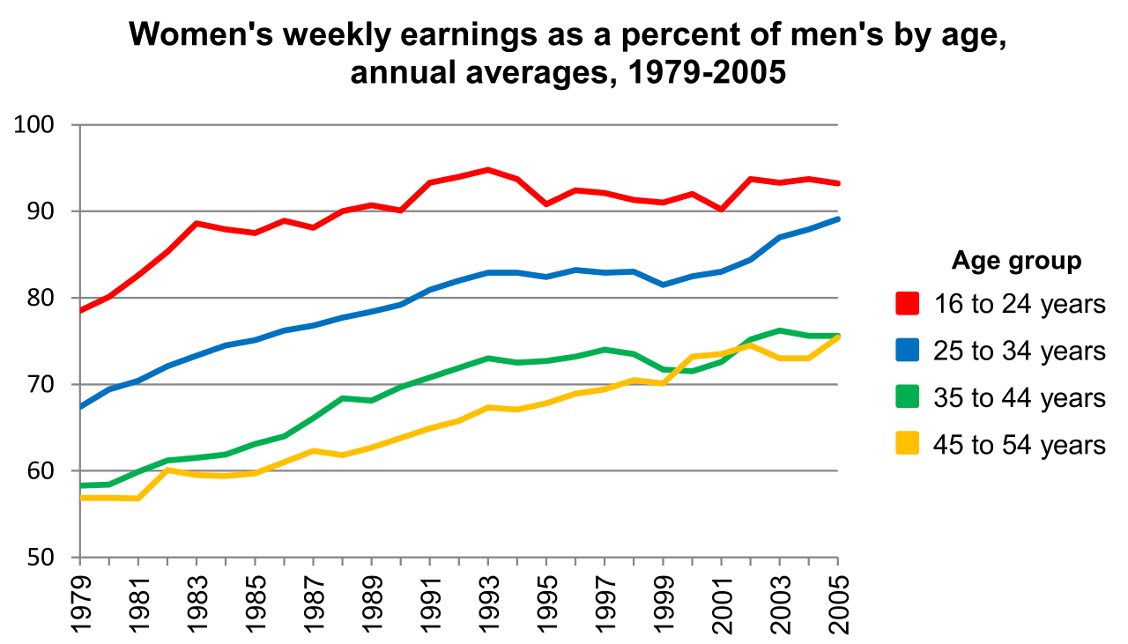

Source: <https://en.wikipedia.org/wiki/Gender_pay_gap_in_the_United_States#/media/File:US_womens_earnings_as_a_percentage_of_mens_1979-2005.svg>

Base on the following graph and this website: <https://www.bls.gov/cps/cpsaat11.htm>, we can see that no matter if there are more women or men in an industry, men would earn more than women do at most industry.

The graphs below are gender wage gap for the most common occupations for women and for men, in order, in the U.S. in 2017, by median weekly earnings (in U.S. dollars). We can see that men still earn more than women in both cases.

In summary, the data states that women are still lacking behind men in terms of earning and salary, hence support my cause.